Homework5

|  |  |  |
| --- | --- | --- |
| 202283890036 | 黄家睿(Jerry Huang) | Internet of Things |

# Basic Shell Commands

In this part, we should familiar with the basic command of the Shell in Unix system.

First we should Navigate to the /home/user/documents direction. Then create a new file in the directory and edit information in the new file.

After that, display the contents in the new files to terminal.

Finally, rename the file name as “testfile_renamed.txt”.

## Navigate directory

We can use `cd` option to navigate the directory.

cd /home/user/documents

## Create file

We can use `touch` command to create d document, and use `echo` command to write in the text.

touch testfile.txt

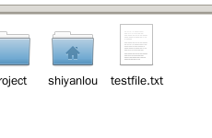

echo “hello world” > testfile.txt  
h



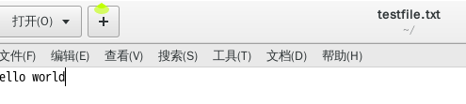

## Display file

We can use `cat` command to display the text in the files into terminal

cat testfile.txt

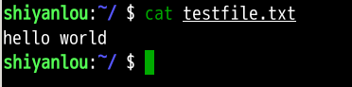

## Rename the file

mv testfile.txt testfile_renamed.txt

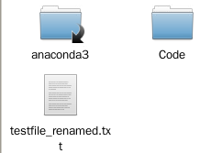

# Unix Manual Use the man command

The man command is used the find the way how to use some commands

## man chmod

man chmod

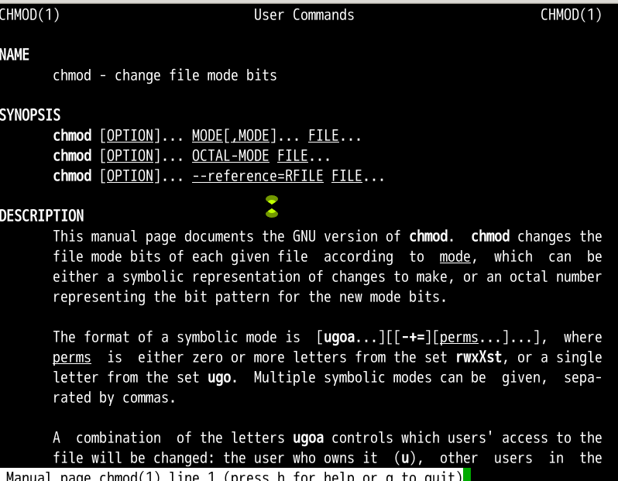

## Is command

man ls

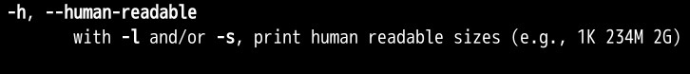

## hidden

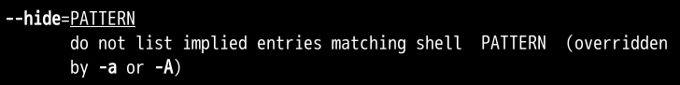

# Vim Editor

:e node.txt



Use i to enter inset mode, then we can edit the file.

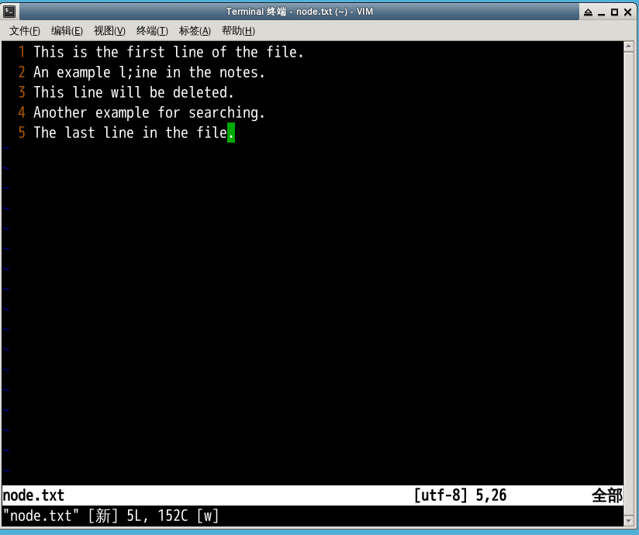

After finishing edition, use :w to store the edition.

## Add new line

In this part ,we will add a new line in to the file.

Use :G, vim can locate the ground line of the file.

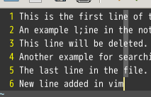

## Delete specified line

We can use `number +G to locate the line, the line is in line 3, so we can enter: `3G` to locate the line 3, then use command `dd` to delete.

3G dd

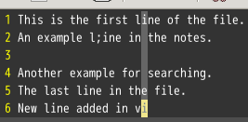

## Search

/ example

## 3.5 Store the file

:wq

After using the code, we can save the changes and exit the vim, then we can check the file and find the changed have saved.

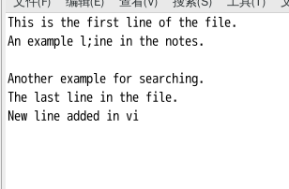

# Create script and operate

## Part 1:

create a script named process_number.sh, prompte user to input five integers, and check if each number is even or odd using an if statement, display the result for each number:

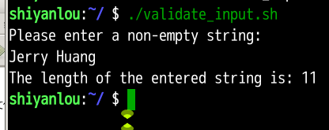

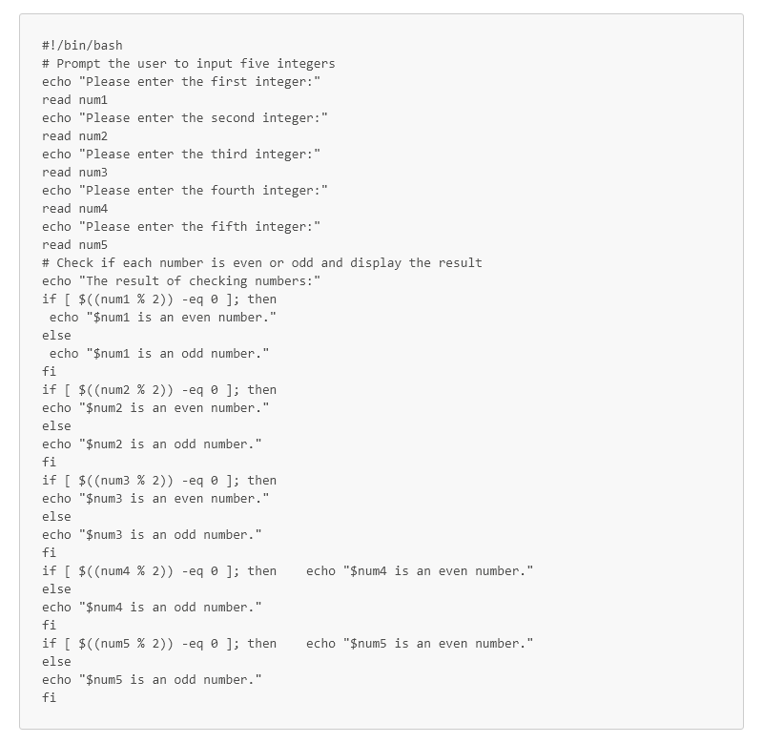

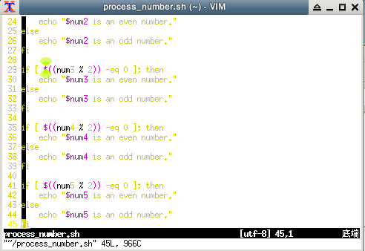

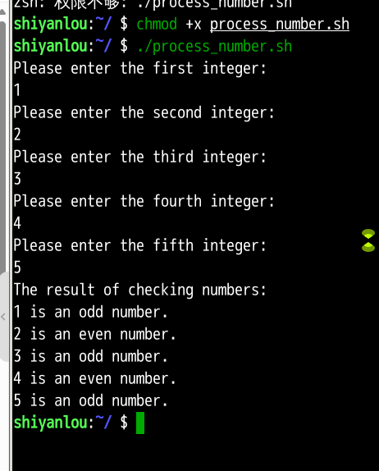

## Part2:

continuously prompts the user to enter a non-empty string using a loop, then validate the input and ensures it is not empty, it the input is empty, it prompts the user again. Once a valid string is entered, display the length of the string and exit.

